To hire suitable candidates, every company conducts various rounds of interviews to measure the candidate’s technical and behavioral prowess. HR interviews are done to gauge the personality- strengths and weaknesses of a candidate to handle the role and then understand whether the candidate is suitable to do the job. Sometimes, the interviews are conducted to decide how well the candidate can fit into the company’s work culture. Generally, these rounds are done at the end of the recruitment process after the technical skills evaluation.

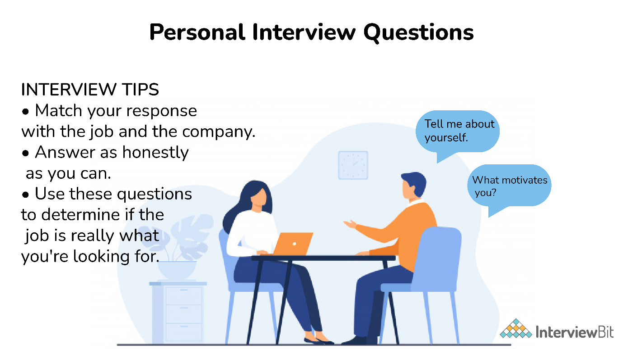HR Interview Questions

The HR interview rounds can make or break your opportunity to join your dream company. Hence it is best to keep some tips in mind to ace this interview.

* Do not fake! Be yourself. Bluffing during the HR interview should be avoided at all costs.
* Answer to the point and while answering, be honest and truthful.
* Wear comfortable but formal clothes. Keep accessories to a bare minimum.
* Reach the venue on time. If the interview is scheduled online, then log in at least 10-15 minutes earlier than the scheduled time and ensure that your connection set up is alright.
* Do not sound dull while answering. Be enthusiastic and interactive with the hiring managers. In case the interview is online, then remember to keep your video on.
* Lastly, have a smile on your face.

In this article, let us see what are the most commonly asked HR interview questions and understand why the questions are being asked and what would be the sample acceptable answers to those questions.

**Traditional HR Questions**

**1. Tell me about yourself.**

This is the universal question asked at the very first of any interview. It sounds easy, right? But this is the most important question where the candidates fail to create an impression with the interviewer as most of the time they are not aware of what exactly needs to be said.

**Some tips to answer this question:**

* Do not ask the interviewer what he wants to know about you. You may be asking genuinely, but that just sounds rude.
* Do not speak what is already there in the resume. The interviewer wants to know what they have not seen on the resume. And do not speak about anything personal.
* Introduce yourself by including certain adjectives like problem-solving, innovation and tech-savvy, creative, quick learner, etc. that best describe you in your professional life to boost your chances.
* Cover what you have accomplished in your career and what work you have done in the past which can help you excel in the position that you are being interviewed for.
* You can also tell why you want the position and how the job is going to be perfect for you.
* Focus only on your strengths that are relatable to the work.

**Sample answer could be:**

I am an energetic person, an effective communicator, and a quick learner. I was also one of the top students in my batch while I was pursuing a B.E degree in the XYZ domain. I worked on various projects related to the software domain which provided me a great deal of technical exposure along with the importance of working in a team and the value of client satisfaction. I have worked on developing various enterprise-level web applications for helping companies solve problems like ensuring business continuity, market research analysis, etc. So, I believe I am a good fit for technology-centric roles in your company.

**2. Why do you want to work for our company?**

Another popular question asked by the interviewer to make sure that the candidate has understood the job requirements and help the interviewer understand the reason behind choosing their company for that job. You should answer in such a way that the interviewer gets convinced that you are a great fit for the role.

**Some tips to answer this question:**

* Talk about the past projects that you had worked on that matches the requirements of the current role.
* Talk about your career aspirations that are associated with this job role.
* Have the knowledge in hand about the company’s vision, mission, and the work it has done in recent years that inspired you to join the organization.

**Sample answer:**

I feel that with my current skill sets and my experience in the XYZ domain, the job requirements this role presented are a perfect match for me. I could visualize myself in that role as it aligned with my career aspirations, skills, and expertise. Besides, I have researched your company and found that it has impressive and promising projections which made me excited to be a part of the amazing future. I would take pride in working under the great leadership of this company and I found this place to be a perfect fit for utilizing my expertise along with the promising aspect of personal growth.

**3. What are your greatest strengths and weaknesses?**

HR asks this question to get to know more about your characteristics and your suitability for the job. It is also one of the standards and most commonly asked questions.

**Some tips to answer this question:**

* Be honest.
* Start by stating the strongest skills and qualities that can be of a great match to the job role.
* Be ready with the backup claim for each of the strengths that you mention. Hence, avoid speaking of the strengths that you do not possess.
* Do not tell any weakness that can potentially jeopardize your candidature.
* Do not mention more than 2 weaknesses and always mention how you are working on improving them.
* Do not tell cheesy, cliché answers like “I am a perfectionist which is both my strength and my weakness”.

**Sample answer:**

I think one of my greatest strengths is that I am a great team player. I am also a self-motivated and quick learning individual. Whatever task that I set to do, I always give my best and complete it diligently well in advance. My weakness would be that I am learning to master people skills while meeting new individuals. I get nervous while talking to new people. I have been working on this for quite a long time and I can say with utmost confidence that I have come a long way.

**4. Why are you looking for a change?**

Yet another commonly asked question for experienced candidates, the interviewer wants to understand what made you look for different opportunities and identify if there are any red flags. Whatever is the reason for changing your job, do not talk negatively about the current employer. Do not divulge information about how bad the work environment was, how poor the salary was as these are of no concern to the interviewer. Keep the answer professional without sharing your woes.

**Sample answer:**

The reason I am looking for change is that I feel like now is the time to expand my horizon. I have worked in my current company for quite a long time and while I am grateful for all the opportunities that were presented to me there, I want to go beyond my current role here, explore different avenues and take up challenging roles and I believe that your company will be the perfect place for me to push and grow myself as an individual.

There might be cases where you might have been laid off due to budget and management constraints. In these cases, you have to convey the below things to the recruiter:

* It happened due to an unforeseen event and it was not your fault.
* You still have a positive mindset about various opportunities that are available in the market.

**Sample answer can be:**

The client that I was working for was leaving the market and hence our company was forced to dissolve the department. Unfortunately, I had joined that position in that department very recently and hence my duration in this company was short. I do not have any regrets though as I was extremely happy due to the learning opportunities presented which will help me a lot in my further career endeavors.

**5. Tell me about the gap in your resume.**

This question comes up when the interviewer finds something interesting and out of ordinary in the resume. Some examples could be a job that could be unrelated to what you are seeking or a job that lasted only for some months or in some cases, the outright gap between two consequent jobs. Here, HR wants to make sure that the gaps are not due to any red flags.

**Sample answer:**

After the completion of my bachelor’s degree, I started working continuously for 8 years without taking any break. This sort of impacted my productivity and also harmed my work-life balance. Hence, I decided to take a break of 6 months to clear my mind, make amends with my family, and also do solo travel to different places. I also gained some lessons during this break such as the importance of work-life balance, organizational ability, and a fresh new perspective on life.

**6. How would you rate yourself on a scale of 1 to 10?**

The main point while answering this question is to not convey that you are perfect. This would indicate that there is no scope for improvement and would showcase yourself as overconfident to the interviewer.

Also, remember to not undervalue yourself too. This would show that you don’t have any self-confidence.

**Sample answer:**

I would like to rate myself an 8. 8 because I know that I am not perfect and there is always a scope for learning and improvement. Continuous learning is the most fundamental part of personal and professional growth.

**7. What is your biggest achievement so far?**

Make sure to discuss only your work-related achievement. Pick up the most recent achievement of yours and answer this question.

**Tips to answer this:**

Answer the question in a STAR format. STAR represents: S: Situation, T: Task, A: Action, and R: Result

**Sample answer:**

I have achieved several milestones to date in my career as a software developer. The most recent one is of the time when we were working on a critical component of a product pertaining to customer payments. We were working round the clock for around 2 months and I was a core developer. I was made a lead to this component for completing the task in another 2 months.

To meet the deadline, we ensured that we upskilled ourselves to learn all the aspects of the development of this module and also brought in a few more resources to complete it faster. Post the deployment, I trained our team to support the platform proficiently. Ultimately, we could complete the product well in advance of the deadline. When the product was launched, the higher management was super proud of us and our team was awarded for our outstanding performance in the quarterly town hall. It was a very proud moment for me.

**8. Where do you see yourself in 5 years?**

Now, this question is the trickiest and deadliest one among all. This can prove to be a trap and you might not even be aware of it. While the question might seem casual, the main purpose of this question is to find out how long you are planning to stay in the company if hired and how your vision fits the vision of the company.

* You might be tempted to answer honestly by saying things about your plans for higher studies, your plans to start a startup, your plans of becoming a hiring manager in the company or if you don’t have a plan then you are simply tempted to say you don’t have a plan at all. These are the things the interviewer doesn’t want to hear and hence avoid giving such answers.
* The recruiter is only interested in knowing how long you are planning to stay in the company and how satisfied you are with the current position you are going to be hired.

**Sample answer:**

Over 5 years, I would love to utilize all the opportunities that this company provides me to learn by utilizing the internal and external training programs. My ultimate career goal is to become a Technology Architect and hence I would look forward to developing various products that represent the vision of this company and be a part of making a difference along with quickening my journey of becoming a Tech Architect.

**9. Why should we hire you?**

The recruiter asks this important question to understand how well you would fit into the position because every hire is a risk to the interviewer in case they turn out to be unfit. Your answer to this question can make or break your interview. Hence, prepare well for this question and make sure to convey to the interviewer why you are the perfect fit for the position.

**Some tips to answer would be to include:**

* How well you would perform the job and how you would be a great addition to the team.
* How you possess the right talent which makes you stand apart.
* Everything should boil down to how you can add great value to the organization.

**Sample answer:**

I am a self-motivated and very open-minded person who can learn very fast. Looking at the job description and my experience in the field of web development, I am confident that I am very much suitable for this role. I enjoy solving problems and I am a great team player. I also believe that my values are aligned with this company’s values. I think this position will support my interest and also give me interesting and exciting opportunities to contribute to the growth of this organization. I am very much excited about this opportunity.

**10. How do you deal with criticism?**

The main intention to ask this question is to see what your attitude towards feedback is and how you react to it. The main point here is to let the interviewer know that you are always open to constructive feedback. You should not show yourself as a stubborn or ignorant person who is not capable of taking any input for your growth.

**Sample answer:**

I am always enthusiastic about learning new things and during the process, I might tend to make mistakes. If someone provides me with constructive criticism, I am always open to it and I will work on correcting myself and learn from my mistakes. This would help me grow and move forward. If the feedback is negative, then I am mature enough to ignore the feedback and continue working on doing my job to the best of my capabilities without dampening my spirit.

**Behavioural HR Interview Questions**

**11. What Are These Behavioural Questions**

These questions are mostly of the format “Tell me about a time…” where you would be asked to share your experience based on certain scenarios which would help the interviewer judge how well you handled various work situations thereby reflecting your skills, capacity, and personality.

Always answer such types of questions using the STAR format to provide structured answers. STAR has the following questions to be answered in the same order:

* **Situation:** What was the situation/event?
* **Task:** What were the tasks involved in the above-mentioned situation?
* **Action:** What did you do to complete the goal?
* **Result:** What was the result of the actions? This is the most important part which conveys if you were successful or not.

Avoid bragging and exaggerating at all costs.

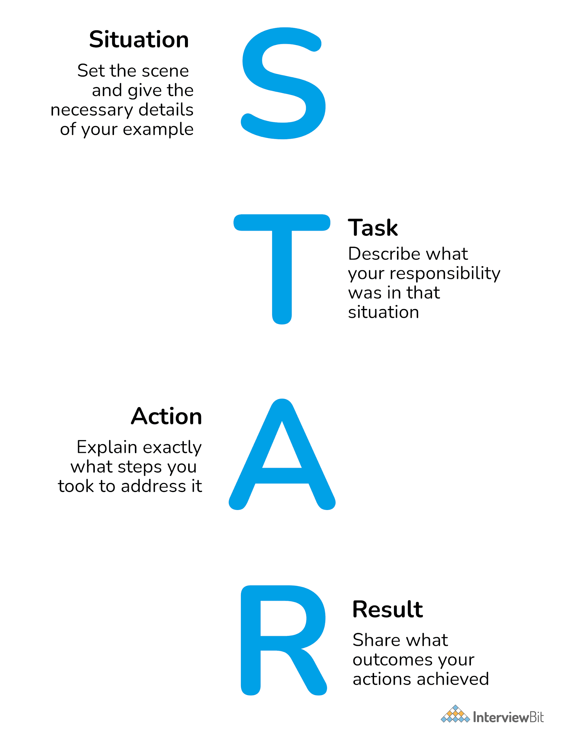STAR

**12. Tell me about a time when you were not satisfied with your performance?**

Here, the interviewer gets to know the extent of ownership you take while performing any task. It also reflects how well you care about the job and the company.

**Sample answer:**

When I initially joined my job right after college, there was a point where I was constantly becoming dependent on the team members to get work done. I did not like this as I wanted to carry out my responsibilities in an independent manner along with working in a team. I wasted no time and quickly learned the working dynamics of the project and received various assignments related to the project. The more assignments I worked on with minimal help, the more confident I became and the more sense of ownership is provided. I felt more independent and I was lauded multiple times for my dedication, my sense of ownership, and how quickly I was able to adapt to the project.

**13. Tell me about a time when you were made to work under close supervision.**

Here, the interviewer evaluates how well you work in a team and how well you can work independently.

**Sample answer:**

In my previous job, I was working under the close supervision of my manager. It felt very overwhelming as the manager watched everything that I do throughout the day and I felt like he/she was virtually sitting by me at all times. I was uncomfortable with this because of the constant pressure involved. But then, I found out that the manager did not trust me enough to do my job alone as I was very new to it. So I worked on building her trust by working very diligently without any complaints in the projects and once I felt the manager was convinced of my abilities, I discussed with her to hand me a project which didn’t involve such close supervision. The manager gave me one such project reluctantly and I made sure I gave my best to it and the project was launched successfully which is how I gained her complete trust.

**14. Can you tell me about a time where you were happy with your work and what was your reaction?**

By asking this question, the interviewer wants to understand what success means to you and what feeling it brings out in you. By this, they can assess your concerns for the growth of the company along with your personal growth.

**Sample answer:**

There was a time in my previous company where I was handling a project related to blogging that would potentially inspire a lot of people. So I worked on researching what topics would people get inspiration from and what would help them be better. I also conducted a survey which I shared with my friends, neighbors and relatives to get better insights about this. When we published the blog, the recognition that we got was tremendous. People loved how relatable the posts were and this turned out to be a significant reason behind the 90% sales of our products. I was very happy with my work as I did my part in contributing to company profits as well as providing a platform to people where they can get inspiration from.

**15. Tell me about a time where you experienced difficulty at work while working on a project.**

Now, this is a broad question as difficulty can be of any type. This question is asked to assess what are the things that you consider as difficult and how you go about solving that difficulty. While answering this:

* Focus on describing a problem that was related to your work using the STAR approach.
* Do not answer negatively or bad mouth any supervisor or any company.
* The interviewer should be made to understand the cause of the problem.
* Avoid bringing up personal problems in your life.
* Focus on the learnings of the problem rather than dwelling too much on the damage.

**Sample answer:**

There was a time in my current company when I received a bug report from our client which stated that the databases were performing below the mark when a complex query was called excessively from the interface.

The first thing I did was checking the logs to perform the root cause analysis. Doing this gave me a rough idea regarding where the bug started appearing. I reproduced the bug only on the production server and I tried replicating the same on my local system. While debugging, I found out that there was a bug in the Java code where some lines were commented out by the developers who had already left this company.

I fixed this code quickly and did a round of performance testing on the application to ensure that this doesn’t occur again. The issue was fixed at the end of the day and we were able to get the server up and running with enhanced performance. We learnt an important lesson to perform regression testing after every phase of releases to ensure the old functionalities were working fine along with the newly developed ones.

**16. Tell me about a time where you displayed leadership skills.**

This question is asked to check how competent you are in a particular situation. You have to ensure that you are not sounding lazy or unprofessional.

**Sample answer:**

I remember this event. Every year, my company used to organize a summer barbeque, and this year, the person who was supposed to organize had left for a new job. I used to volunteer for this before so I volunteered myself for organizing the barbeque this year.

The annual barbeque was a potluck event with some fun activities planned throughout the day. I conducted a survey amongst the employees to see what kind of activities they were interested in. I made a list of those activities and created teams dedicated to conducting each of them. I also ensured that activities did not cross the budget allocated and took care of sending out regular reminders to track the progress of the team. I sent out posters and went through the office floors with a team of people to make sure people are aware of what exciting things we have planned for them and ensure that they arrive at the venue on time. The day of the event was an amazing one. As we had everything planned, the event went on smoothly and everyone had loads of fun.

I received great appreciation from the higher management for my organizational skills and everyone said that they had a great time.

**17. Was there any point in your career where you made any mistake? Tell me about it.**

Now here is a tricky behavioral question and if you don’t answer this carefully, you would be digging your own grave. The interviewer wants to understand what kind of mistakes you made, how did you approach it and how well you would perform if you are hired for the job. Some tips to answer the question:

* Talk about a mistake you made which you were able to rectify and which didn’t cause any critical damage to your organization.
* Talk about what you learned while working on fixing the mistake.
* Avoid any mistake that represents any flaw in your personality.

**Sample answer:**

I remember an instance when I joined my first company. I was asked to work on two projects simultaneously and I accepted it even though I knew I would not be able to handle it. I did not want to tell my manager that I cannot handle it as I did not want him to think less of me. I was not supposed to tell either of clients that I was working on another project which caused me double stress due to which I was not able to meet the deadlines for the assignments. I realized I should have clearly communicated this with my manager and then my manager understood the situation and allocated a new resource to work with me to complete the project delivery. I learned the importance of keeping my supervisors updated with any task and being open to them if I am facing any roadblocks.

**18. How did you handle disagreements with your manager?**

The interviewers want to know how well you deal when your ideas are disagreed by your manager/supervisor. Disagreements are part and parcel of working in a team. Hence, the recruiter wants to know if you are capable of handling such disagreements and how well you plan to develop the relationship with the manager.

**Some tips to answer this question:**

* Explain what the disagreement was.
* How did you overcome that?
* What was your learning outcome?
* Do not speak ill or abuse your manager.
* You can not tell that you never had a disagreement before as it would just prove that you do not have a sense of leadership or you lack creativity.

**Sample answer:**

This reminds me of an instance where I and my manager had a disagreement on why a certain feature has to be included in the product and he was against it. We had lots of discussions regarding the pros and cons of that feature. During this, I explained to him why adding that feature to our website would be the best thing to do and how it would make the lives of our users easier. I gave him various scenarios and good reasons why that feature would be a great idea. My manager was convinced as he felt the reasons were good enough and we got his green signal to work on it. In the end, when we unveiled this feature to our client, the clients were indeed very happy and praised us all as we went out of our way to add this feature. My manager was very happy with the result. I learned that effective and graceful communication is the ultimate key. Ideas should be respectfully conveyed to people when there are disagreements as we belong to a team and the collective vision of the team is to launch the project successfully. In case my manager’s idea was best for the project, then I would gracefully accept that too.

**19. Tell me how you will handle it if suddenly the priorities of a project were changed?**

Here, the interviewers want to know how the candidate will act in the situation when priorities are changed. This will also reflect the candidate’s ability to handle stress and solve problems.

**Some tips to answer this question:**

* Make sure that you convey the right things to the interviewer.
* Give instances of how well you are capable of handling pressure and stress.
* Avoid boasting and no matter how frustrated you were during these situations, do not tell the interviewer.

**Sample answer:**

I certainly understand that there might be valid reasons for a company to change the priority of a project. The vision of a project at one particular point of time would change at another time due to various conditions. If the priority of the task that I work on gets changed, I will put efforts into understanding why this happened and I will consider that it is in the best interest of the company and start to work on the new task of higher priority rather than crib about it. The ultimate goal is to achieve big things by putting in my best efforts.

**Opinion based HR Interview Questions**

**20. Consider the scenario - You win a million-dollar lottery. Would you still be working?**

Generally, these questions would be based on the cases or scenarios. This is to understand how you think and execute the plan in a given situation.

Opinion Based

This question is a big trap! If you answer “yes” to this, then you will be considered a materialistic and money-minded person who could easily give up on the company if you are provided with a lot of money. And hence, you won’t be a valuable asset to the company.

**Sample answer:**

I will be super thrilled if I win such a lottery as it would mean that I would be having a hefty saving for me and the future of my family. I won’t be quitting my job because I enjoy my work and I love learning new things continuously and I would still love to explore more domains. My only wish is to retire after completing a very fulfilling career.

**21. What would you do if you were working under a bad boss?**

Interviewers want to know how well a candidate can cope up with people with different beliefs and ideologies and hence it can get a little tricky to answer this. While answering this, you ensure that you are avoiding emphasis on the negative aspects of the situation.

**Sample answer:**

Firstly, before jumping to the conclusion that my boss is bad, I will try my best to understand his personality and get to know what their problem is. If I find my boss to be aggressive, then I will make note of the things that would make him angry and will work on avoiding that. I will also try asking my colleagues how they have worked on dealing with him. If things get worse, I will contact HR to get a solution regarding this.

**22. What do you think is an ideal work environment?**

The main intention of this question is to understand if you will fit into the work environment that the company has already. Employers want to ensure that the employees are more productive and happy doing their work and retain them in the long run and hence they ask this kind of question to understand if the employees can fit into their culture.

**Some tips to prepare for this question would be:**

* Thoroughly research the company you are interviewing for and have a brief idea of the work culture, the hierarchy of the company, etc.
* Talk about the work culture that would focus on growth.
* Emphasize how a team-oriented workplace would be of interest to you.
* Ensure that whatever you talk about is aligned with the company’s vision.
* Avoid mentioning a workplace that gives a lot of vacations, flexible timings, more bonuses, and fun. We know it is ideal, but it doesn’t work that way.

**Sample answer:**

According to me, an ideal work environment is one that revolves around a team where the focus is on learning, working, and growing together to take the team members and the company to new heights. It is where the skills and capabilities of team members are being leveraged to grow. While I was researching your company, I found that you pay more importance to teamwork and that was something which impressed me. I believe that I can work better in an encouraging environment.

**23. What does motivation mean to you?**

This again is a broad question that can be easily misinterpreted by the candidates. While answering this question, we have to make sure that we are honest and also our answer should be associated with the job that we are getting interviewed for. Try giving an example to make things more clear.

**Sample answer:**

Learning new things and the feeling of satisfaction that comes while solving a problem drives me to do my best in my job. I love challenges as they push me to do more. I believe that learning should never end and the day we stop learning is the day we get stagnant and this thought always motivates me to learn something new. Looking at the job description, I know that this job will provide me the motivation to keep things going.

**24. What is your dream company like?**

This a tricky question where the interviewer again assesses your rightness for the job. While answering this, do not spill out your actual dream of working for 6 figure salary in a company with frequent access to vacation and flexible work hours. The interviewer is not interested in these things and will consider these as red flags as they make you seem materialistic.

**Some tips to answer this:**

* Be sincere in what you want in an ideal workspace.
* What you say should align with the work culture of the company.
* Avoid exaggeration and point out a specific employer as an example.

**Sample answer:**

My dream company is a place that would provide me loads of opportunities to learn and grow and help me harness my abilities to contribute to the overall growth of the company. I value such a company that will recognize and appreciate performance and based on what I have researched about your company, I believe this place can offer me these opportunities.

**25. What do you do to ensure that a certain number of tasks is completed effectively?**

By asking this question, the interviewer understands how you will perform while multitasking. These days, every employer expects that a candidate should be able to work on multiple projects simultaneously which is where understanding how capable you are to multitask becomes important to them.

**Some tips to answer the question:**

* Describe a situation where you worked on multi-tasking and how you were able to meet up the deadlines.
* Do not talk about how much you hate multi-tasking.
* Do not talk vaguely or give generic answers.
* You can also give examples to back up your claim in STAR format.

**Sample answer:**

Whenever I am assigned multiple tasks, the first thing I do is to calm myself down and build up a positive mindset that I can achieve the task. I then begin to organize them based on the priorities and come up with a plan to set deadlines for each of them and begin to work on the task. Whenever I feel like I am blocked or I am facing roadblocks, I let my supervisor know of this and I don’t hesitate to seek help from my colleagues. If I see that I am not able to meet the deadlines, then I will be informing my manager well in advance by detailing whatever I have done. Most of the time, my manager was kind enough to understand the cause of delays and I would receive an extension in the deadline and I ensure that my tasks are completed.

**26. What would you prefer - being liked or being feared?**

The answer should be given diplomatically here because no interviewer would want a candidate who likes to be feared.

**Sample answer:**

Honestly, I prefer to be well respected in my organization. Fear does not command respect. I want to be in such a way that my team members will not hesitate to reach out to me for anything.

**27. How long do you think you will be working for us if you are hired?**

The recruiter wants to check for how long you will be staying in the current company. Do not be honest and share your plans of switching to a dream company or your plans of higher studies.

**Sample answer:**

I am planning to be in this company for a very long time as long as I am being valued and respected for my work and as long as the management sees me as an asset.

**28. If you were reborn as an animal, what animal would you want to be?**

This might seem to be an odd question to answer to. Rest assured, the interviewer does not want to joke with you. Instead, they ask this question to get what kind of personality you are, what your thought process is, and how creative you are by describing yourself as an animal.

**Some tips to answer this question would be:**

* While answering, make sure your justification is aligned with the job role you are choosing.
* Do not choose animals with poor traits.
* Do not choose animals with the traits that are opposing the ones required for the job role.
* Following are some traits of animals. Make sure your skills match those traits:
  + Lion: Always ready to fight, never backs from challenges, strong and rightly known as the king of the jungle.
  + Dog: Known for loyalty and friendliness.
  + Elephant: Hardworking animal capable of performing hardcore work.
  + Cows: Known for love and loyalty.
  + Dolphin: Known for selflessness and helpfulness.
  + Butterfly: Has the ability to transform from one stage to another and always waiting to fly beautifully.
  + Ant: Known for being a hard worker and for the ability to carry weights twice their weight.
  + Owl: Wise creatures known for seeing bigger pictures.
  + Dove: Known for peace and non-violence.
  + Chameleon: Jells well in all environments. Also considered to be sneaky. - This animal can be avoided.
  + Snake: Known for being tricky - This animal should be avoided.
  + Tortoise: Known for being lethargic and sluggish. - This animal should be avoided.

**Sample answer:**

I would like to be reborn as a lion. A lion is known for its love for challenges and its pride. It goes for what it wants and it can thrive in a battle (or challenge) which is why I want to be a lion.

**29. Will you lie for the company under any circumstances?**

To be honest, this question is not commonly asked anymore. However, just be prepared for this question. It is a tricky one to answer as you have the question of integrity and the company benefits in line. The best thing to do here is to be diplomatic.

**Sample answer:**

I believe in the principle of honesty. So, my willingness to be a part of the lie would depend on the situation and the outcomes associated with it. If my lie will not jeopardize anyone and brings a positive result for the company and the employees, then I can be a part of it. However, I do not feel good about lying.

**Brainteasers HR Interview Questions**

**30. What do you think is better - being perfect and delivering late or being good and delivering on time?**

Brainteasers

Back up your opinion with certain examples and answer what according to you is right.

**Here is one possible answer:**

I believe that it is always better to be good and deliver on time. Time is money to the organization. If we are good and on time, then there is always room for improvement and enhancements. But if we deliver it late, then no amount of perfection can make up for the time lost.

**31. Judy’s mother had 4 children. The eldest one was April, the second child was May and the third child was June. What was the name of the fourth child?**

This is a very simple question. Yet some people find it confusing when they hear it for the first time or possibly due to the stress of interviews. Think twice before answering. Never say that you do not know. At least try solving.

The answer is **Judy.**

**32. How many times in a day does the clock’s hand overlap?**

While hearing this question for the first time, it might sound very simple but it could also be complex. Interviewers do not generally look for the correct answers. They would just want to see how well you are capable of analyzing a problem and what is your thought process to approach a problem.

**Some tips to answer this question:**

* Take time to analyze the answer.
* Note down your thought process while answering.
* Show that you are actually in the process of solving a problem.
* Do not blurt out answers without thinking.
* Do not say I don’t know without even trying.

**Sample answer:**

We know that we have 24 hours in a day. The hand first overlaps at 12:00, then at 1:05, 2:10, 3.15, 4:20, 5:25, 6:30, 7:35, 8:40, 9:45 and 10:50 two times in a day. There will be no overlap at 11:55 because the hour hand is moving towards 12 while the minute hand is at 11. This sums up the result to 22.

**33. You have only two vessels of 3l and 5l volume and you are given an unending supply of water. Can you find out how to get 4l of water just by using these two vessels?**

Take time to analyze the question. Do not think silently. Let the interviewer know of your thought process.

**The answer to this question is:**

* First, fill the 3l vessel with water.
* Transfer all the water from the 3l vessel into the 5l vessel.
* Refill the 3l vessel again and pour it off into 5l vessel jug till it is full.
* In the 3l vessel, we now have 1-litre of water available.
* Empty the water from the 5l vessel completely.
* Pour the 1-litre water from 3l vessel to 5l vessel.
* Fill the 3l vessel with water and pour this into the 5l vessel. We now have 4l of water in the 5l vessel.

**Salary Related Questions**

**34. What to expect?**

These kinds of questions are asked to find out if the interviewers can afford to hire you based on their budget and the range that they wish to offer. They want to ensure that your expectations and the range provided by the company are aligned and you are satisfied with it. It is very important to know and realize yourself worthwhile answering these questions especially when your expectations are more than what they are expecting to provide.

You do not want to come across as a money-minded person nor do you want to come across as a saint who is happy with being underpaid. Also, this is the part where your negotiation skills also come into play.

Salary Questions

**35. What is your current salary?**

This question is asked to make sure that the money that you make in your current position falls within the budget that the interviewers want to provide you with.

* Try your best to avoid telling your current salary.
* In the current hiring market, companies do not add anything more than 35%-40% of the current salary.
  + Only in some cases where you are found to be the most perfect fit after excelling in all the rounds of the interview, the companies would be willing to offer you more hikes.
  + Some companies have a specified range dedicated to a particular position.
* However, the job of the recruiter is to hire a candidate who can do more at less cost. Hence, disclosing your current income might land you in an unfavorable position.

**Some tips to answer this would be:**

* Research about the salary provided by the company to that particular job role either by checking on websites like Glassdoor, Indeed or by connecting with people working in that company on Linkedin.
* Avoid stating your current income.
* Ask the interviewer what is the range that he/she is providing for the role.
* Do not lie.

**Sample answer:**

I am not allowed to disclose my current salary information as my employer considers it confidential information and I am bound to that agreement. However, if you share the range that you would be provided for this position, I can let you know if my salary is in that range. Or I can also give a salary range that is based on my research of the company and based on my skills.

**36. What is your salary expectation?**

You have to answer this question carefully as you do not want to get underpaid for the job role at the end of the day.

**Some tips to answer this question:**

* Research about the salary range the company is providing for the position.
* Try to get a range from the interviewer and see if you are okay with it. If the interviewer still insists on you providing a number first then give a range that you are looking for.
* You should be ready for negotiation, hence consider a range where you are okay with even if salary gets negotiated.
* Do not simply blurt out a range. Explain why you deserve it.

**Sample answer:**

I have been in the software development industry for around 6 years. I have worked on developing and launching so many projects and have come a long way from being a fresher. I have also demonstrated leadership capabilities which I think will also be an added asset for you along with my technical prowess. Considering all this and also based on my research, I think if my compensation falls in the range of ₹15,00,000- ₹20,00,000 then it won’t be a bad idea.

**37. How much do you think you should be paid by looking at your qualifications?**

By asking this question, the interviewer checks if the candidates are aware of their self-worth and indirectly want to know what money you are expecting. Do not be humble and modest while answering this question. You should sell yourself and prove that you are aware of what you are worth.

**Some tips to answer this question:**

* Research about what is the current market trend for the skills and capabilities that you possess.
* Let the interviewer know that you have great skills by really selling yourself.
* Do not undermine or downplay your skills just to please the recruiter.
* Do not say a specific amount right away. Back it up with why you think you are worthy of that money.

**Sample answer:**

I have been in the software development industry for around 6 years. I have worked on developing and launching so many projects and have come a long way from being a fresher. I have also demonstrated leadership capabilities which I think will also be an added asset for you along with my technical prowess. Considering all this and also based on my research, I think if my compensation falls in the range of ₹15,00,000- ₹20,00,000 then it won’t be a bad idea.

We have seen what are the most commonly asked HR interview questions, why they are being asked, some tips to answer each question, and also possible sample answers to them. The list is quite comprehensive. Sometimes, an HR might also ask role-specific questions to know how well you have understood the job role. The questions asked during this round might seem to be a general casual discussion, but you have to be well prepared to answer this as the HR round is the most important round and the only step away from your dream job. The below image is the summary of all the tips that you can utilize to ace this interview.